Problem Reported
DA MODULE (ItemSupplierDynAsm): scaExport - DA -ContextExtractor (defined a policy that selects 1 endpoint, the endpoint is a sca invocation to next module) MEDIATION MODULE (DBMSServiceMediatio): scaExport - modiation - SCAImport

Direct invokation of the mediation works fine. When the same mediation is invoked by the DA the following exception is thrown:

Module: DBMSServiceMediation
com.ibm.ws.sibx.smobo.util.SMONotValidException: CWSXM2003E: The
contents of '/' in the ServiceMessageObject did not meet their
constraints because of CWLBN1014E: The property 'parent-context' of
'{http://www.ibm.com/xmlns/prod/websphere/fabric/6.0.0/context}FabricContextType' is not nillable, but has a value of null. at
com.ibm.ws.sibx.smobo.util.ServiceMessageObjectValidationHelper.
validate
(ServiceMessageObjectValidationHelper.java:167)
at
com.ibm.ws.sibx.mediation.primitives.dblookup.DatabaseLookupMediation.mediate(DatabaseLookupMediation.java:630)
...

Defect(s) Found

When the mediation is called through DA, it adds a context in soap header. Based on context information DA builds appropriate policy at runtime to select a right endpoint.

In case, the selected endpoint is a mediation endpoint, it performs XSLT transformation calling the SOAP message validation. Failure of this validation against XSD schema causes the above mentioned issue.

Fixes Made
XSD schema has been modified to accept null value in 'parent-context' element.

Installing Fixes
Use the following procedure to install this fix.
- Launch WPS admin console.
- Select Application -> Enterprise Applications
- Select Fabric Engine application and click “Update” button.
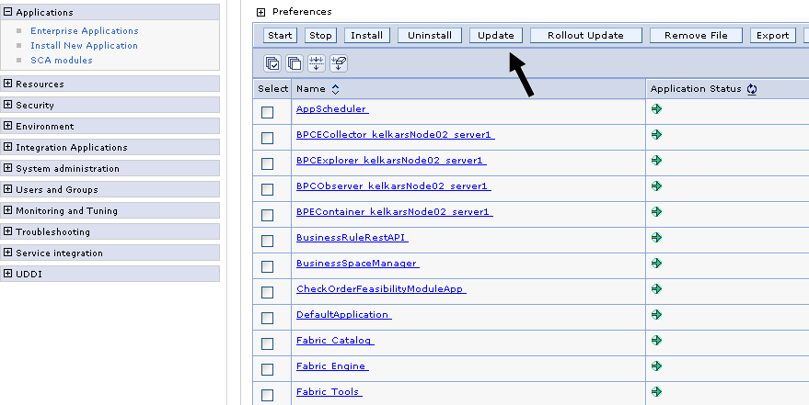

- Select the option “Replace or add a single file”
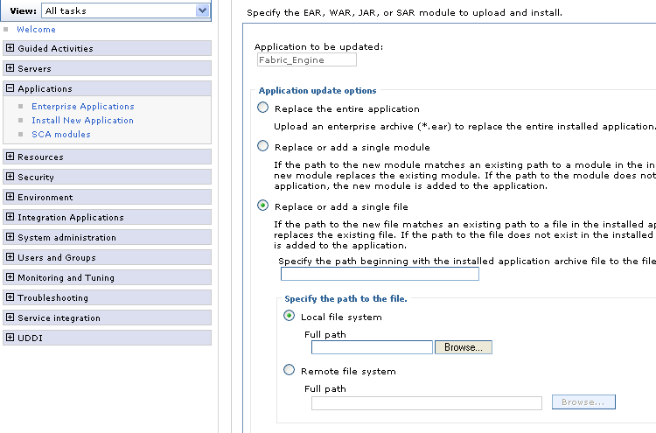

- Specify the path beginning with the installed application archive to the file to be replaced as /lib/fabric-da-model-8.0.jar
- Click browse and select the updated fabric-da-model-8.0.jar file and click next.
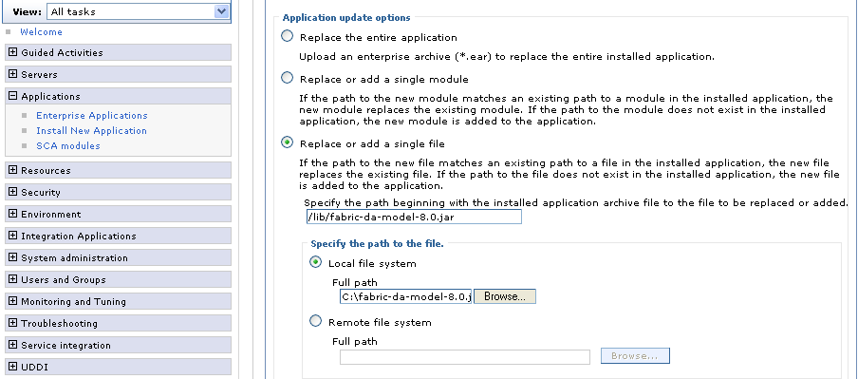

- Click OK
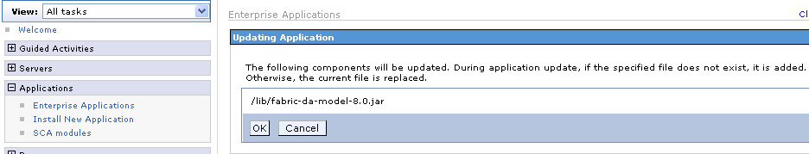
- Click Manage Applications
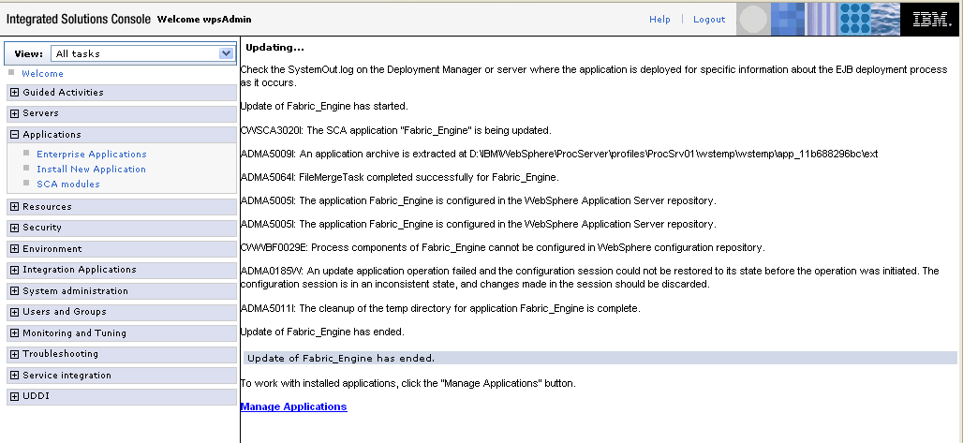
- Finally click Save to save the changes. This will restart the Fabric Engine application.
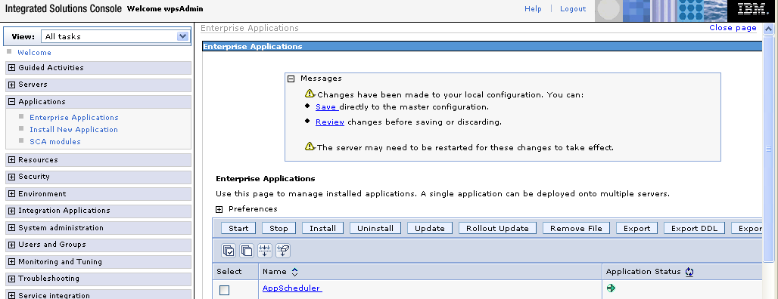
- Stop the WPS server
- Go to the %WPS_INSTALL_DIR%\lib\ext directory.
- Take the backup of fabric-da-model.jar and replace it with updated fabric-da-model-8.0.jar
- Start the WPS server.
Now you are ready to test your application.

