Problem :

PMR 00588,Z00,760 : IJH100HZ -- Japanese double-byte characters in assertions

WBSF Tool Pack 6.1.2 does not show DBCS (Japanese double-byte
characters) assertions.
Windows
WebSphere Business Service Fabric Tool Pack 6.1.2
WebSphere Integration Developer 6.1.2
WebSphere Process Server Test Environment 6.1.2
WebSphere Business Modeler 6.1.2
Rational Software Architect 7.0.0.6
Installation Manager 1.1.2
.
Problem : WBSF 6.1.2 does not show assertions properly when DBCS
characters are used. DBCS assertions are not shown at all, or
each assertion appears twice (redundantly).
===============================================================

Solution :
Updated the CUri.java file present in fabric-support-common-8.0.jar to return the URI as is instead of converting it to Ascii string.
Need to update all the 3 ears i.e
- Fabric-Engine (fabric-engine-ear-8.0.ear)
- Fabric-Catalog (fabric-catalog-ear-8.0.ear)
- Fabric-Tools (fabric-webtools-ear-8.0.ear)
as well the studio core puglin jar file (com.ibm.ws.fabric.studio.core_6.1.2.jar)
as per the steps mentioned below at the clients side
- Launch WPS admin console.
- Select Fabric Engine application and click “Update” button.

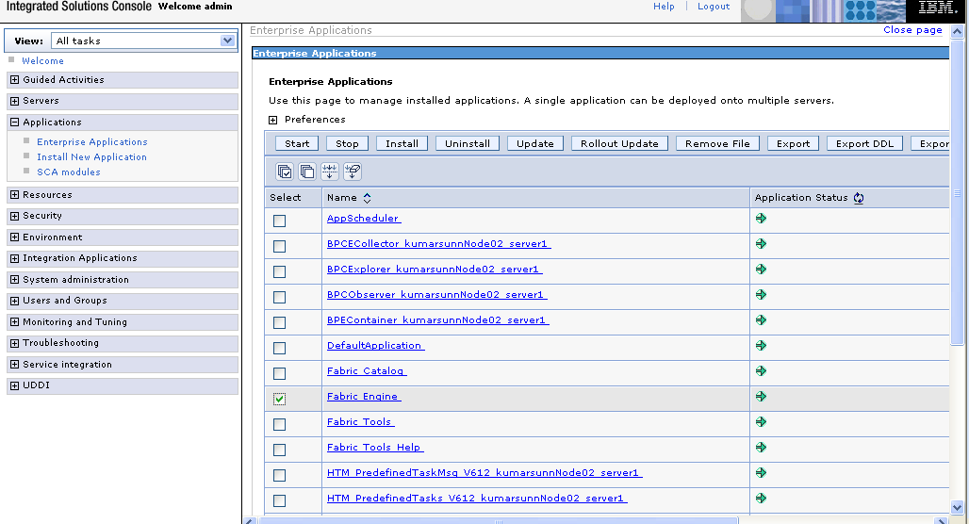

- Select the option “Replace or add a single file”

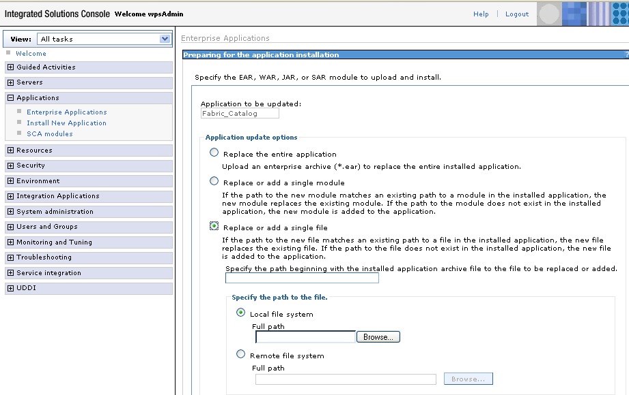

- Specify the path beginning with the installed application archive to the file to be replaced as /lib/fabric-support-common-8.0.jar
- Click browse and select the updated fabric-support-common-8.0.jar file and click next.
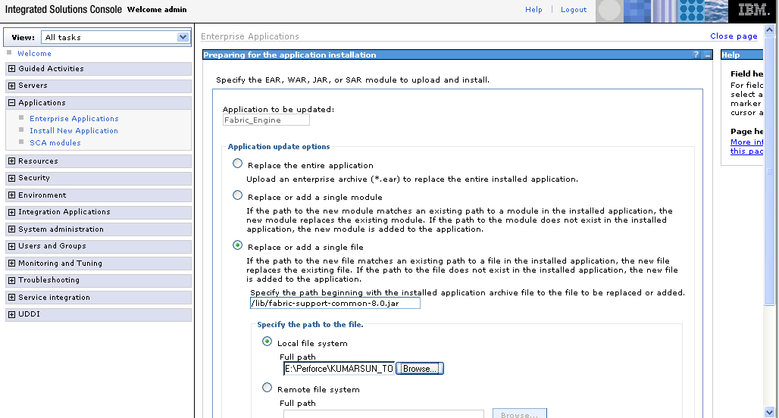

- Click OK

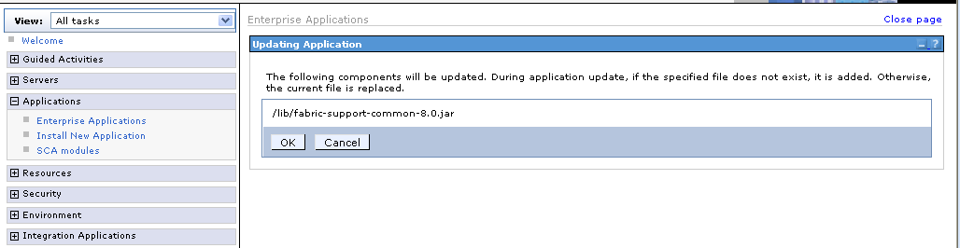

- Click Manage Applications

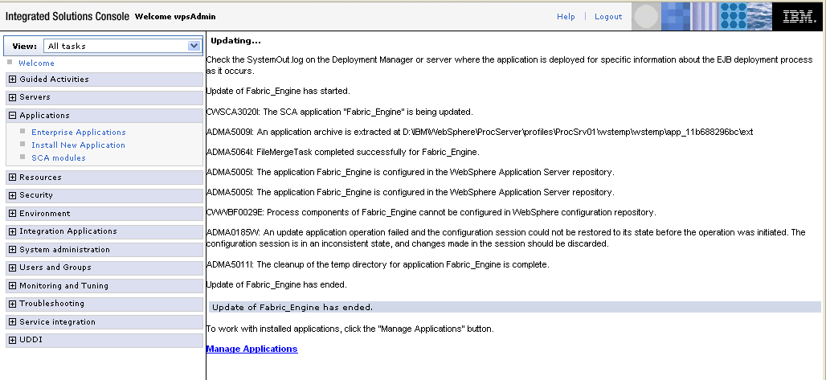
8. Finally click Save to save the changes. This will restart the Fabric Engine application.
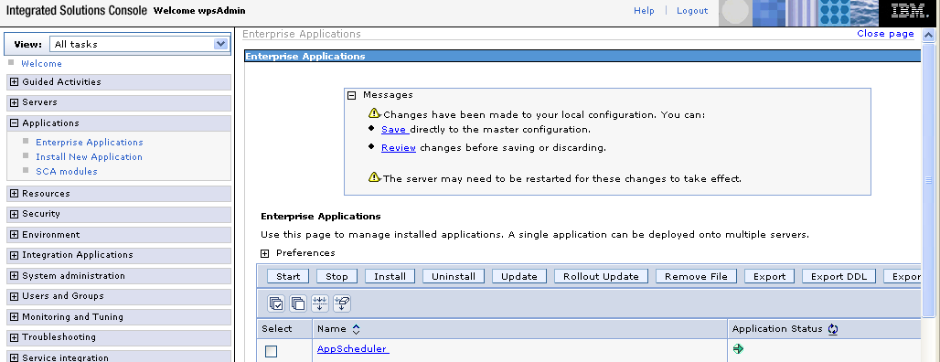
9. Repeat steps 2 to 8 for the remaining 2 ears i.e Fabric_Catalog & Fabric_Tools.
10. Replace the com.ibm.ws.fabric.studio.core_6.1.2.jar file under <WID_INSTALL>\plugins folder with the updated one.
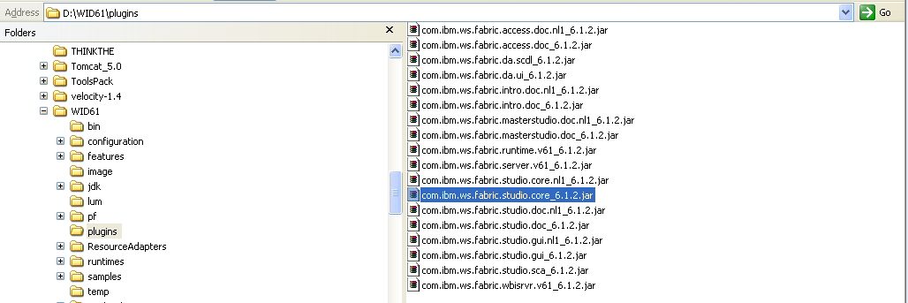

11. Re-start WID using –clean option.
a. Close WID in case it's already open.
b. Open command prompt.
c. Execute <WID_HOME>/wid.exe -clean.
12. Import an empty ontology definition to clear the existing ontology definitions.
13. Import the ontology definitions that are going to be used.
14. Run update on "Composite Studio".

